

CY-3001

Network Security

Semester Project

Project Title:
Enhancing Detection with Zeek and Machine Learning:
Addressing Wazuh’s Signature Limitations

Submitted by: Sarita Sangrez, Shanzay Shah, Laiba Nasir
Roll numbers: 23i-2088, 23i-2016, 23i-2079
Date: 23rd November 2025

Table of Contents
Abstract 4
Introduction and Problem Definition 4
Problem Definition 4
Why the Problem is Complex 4
Background and Related Work 4
System Design and Architecture 5
System Components and Workflows 5
Workflow 5
Implementation Details 5
Tools and Frameworks 5
Datasets 5
Wazuh Installation 5
pfSense Configuration 6
Zeek Installation and LAN Configuration 6
Demonstration of Complex Problem Solving 7
Wazuh & Zeek Integration 7
Wazuh Network Configuration 7
Detailed Steps (Soneye & Singh, n.d.) 8
DNS Tunnelling Signature Based Detection 11
Environment Setup 11
Generating DNS Tunnelling Traffic using Iodine (iodine, n.d.) 11
Zeek logs containing DNS tunneling queries 12
Custom Wazuh Rules for DNS Tunneling Detection 12
Bypassing the DNS Tunnelling Detection Rules 13
Zeek Log Results containing Short Queries 14
Machine Learning Based DNS Tunneling Detection Setup 15
Overview 15
Dataset Collection & Lab Setup 15
Dataset Construction 15
Feature Engineering 16
Machine Learning Models Used 17
1. RandomForest Classifier 17
2. XGBoost Classifier (best performer) 17
Testing, Evaluation, and Results 18
On Jupyter Notebook: 18
On Wazuh Dashboard using zeek and python script: 20
Log Normalization (Python Script) 20
Custom Log Decoding (local_decoder.xml) 20
Custom Alerting Rule (local_rules.xml) 20
Screenshots for proof: 21
Challenges and Limitations 21
Future Work 22
Conclusion 22
References 22

Abstract
Traditional SIEM solutions like Wazuh rely heavily on signature-based detection to identify threats, which limits their ability to detect novel or obfuscated attacks. DNS tunneling is one such method attackers use to exfiltrate data or maintain command-and-control channels, often bypassing static detection rules.
This project explores the integration of Zeek, a network traffic monitoring platform, with machine learning classifiers to enhance detection capabilities. Malicious DNS queries were generated using iodine and dnscat2, while benign queries were collected from normal traffic. Features such as query entropy, subdomain length, digit and letter ratios, and base32 character indicators were extracted for model training. Using RandomForest and XGBoost classifiers, we demonstrate that machine learning can detect both obvious and subtle tunneling domains, including short or encoded variants that static Wazuh rules would miss, providing a more adaptive and robust security solution.

Introduction and Problem Definition
Network security is increasingly challenged by sophisticated attack techniques that bypass conventional perimeter defenses. DNS tunneling is a prime example, where attackers encode data within seemingly benign DNS queries to evade detection.

Problem Definition
- Static rules and blacklists in traditional SIEM platforms like Wazuh often fail to detect dynamically generated or high-entropy domains.
- Malicious actors exploit network protocols (like DNS) for covert data exfiltration or command-and-control communication, which is hard to detect with conventional monitoring.

Why the Problem is Complex
- Scalability: Modern networks generate millions of DNS queries daily, making manual or rule-based inspection infeasible.
- Data Variety: Attackers can craft domains of variable length, encoding schemes, and randomness.
- Automation Needs: Real-time detection and classification are essential to prevent potential breaches.
- Multi-Criteria Decision-Making: Detection requires combining features like entropy, subdomain structure, character distribution, and domain length, which traditional rules cannot effectively evaluate.
This project tackles these challenges by enhancing Wazuh’s detection with Zeek-based monitoring and machine learning classification, allowing the system to identify novel tunneling attempts automatically.

Background and Related Work
- DNS Tunneling: A method for covertly transferring data by embedding it within DNS query/response traffic. Widely used for exfiltration and C2 communications.
- Static Detection Limitations: Signature-based SIEM rules are effective for known threats but fail against new, encoded, or short tunneling domains.
- Machine Learning Approaches: ML can classify domains based on statistical and structural features rather than relying on exact matches. Features such as entropy, subdomain/domain length, digit ratios, number of dots, longest chunk, and base32/base64 character ratios are indicative of tunneling. RandomForest and XGBoost are commonly used classifiers that handle non-linear relationships and imbalanced datasets effectively.
- Zeek: An open-source network monitoring platform capable of logging detailed DNS query information in real-time, providing a rich dataset for ML feature extraction.
- Related Work: Previous research (Bubnov, 2019) has shown the effectiveness of ML classifiers in detecting DNS tunneling, particularly when combining multiple statistical features.
By integrating Zeek’s monitoring capabilities with ML classifiers, this project extends traditional signature-based detection, addressing limitations of static Wazuh rules and improving detection of both obvious and subtle tunneling activity.

System Design and Architecture
System Components and Workflows
The system integrates three main components:
- Zeek: Monitors DNS traffic, extracting detailed logs including queries, responses, source/destination IPs, and protocol metadata.
- Wazuh SIEM: Collects and aggregates Zeek logs, applying signature-based rules for known threats. Alerts from Wazuh are used as a baseline for comparison.
- Machine Learning Module: Processes Zeek DNS logs, extracts statistical and structural features (e.g., entropy, subdomain length, digit ratios), and classifies domains as normal or tunneling.
Workflow
Firstly, Zeek monitors the network and logs DNS queries. Logs are parsed and features are extracted for ML classification. The ML model predicts tunneling activity, supplementing Wazuh’s static alerts. Lastly, alerts are generated when either Wazuh or ML detects malicious activity.

Implementation Details

Tools and Frameworks
- Zeek: For DNS traffic logging.
- Wazuh: For SIEM aggregation and baseline detection.
- Python: For ML preprocessing, feature extraction, and model training.
- Scikit-learn and XGBoost: For RandomForest and XGBoost classification.
- Iodine: For generating synthetic DNS tunneling queries.
- Jupyter Notebook: For training the models.
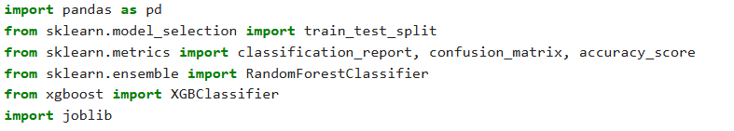

Datasets
- Normal DNS Queries: Collected from benign traffic logs.
- Tunneling Queries: Generated using iodine for two controlled domains (.tunnel.lab and .exfil.shanzay.lab).

Wazuh Installation
A Wazuh VM was deployed to act as the SIEM and automated response engine. The installation included setting up the Wazuh Manager to collect and process security events. Default configurations were applied to ensure the VM was accessible over the lab network, and system resources were allocated to support real-time log processing.
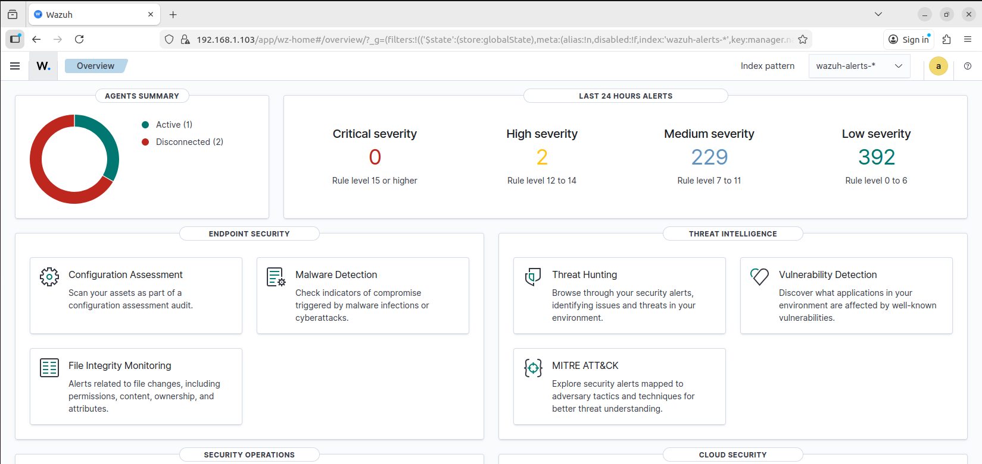

pfSense Configuration
A pfSense VM was installed to serve as the network gateway and firewall for the lab. Its LAN interface was configured with the subnet 192.168.1.0/24, providing DHCP and DNS services for the other VMs in the environment. This setup allowed Zeek to monitor all internal traffic passing through the LAN. Firewall rules were kept minimal initially to ensure free flow of traffic for testing and monitoring purposes.
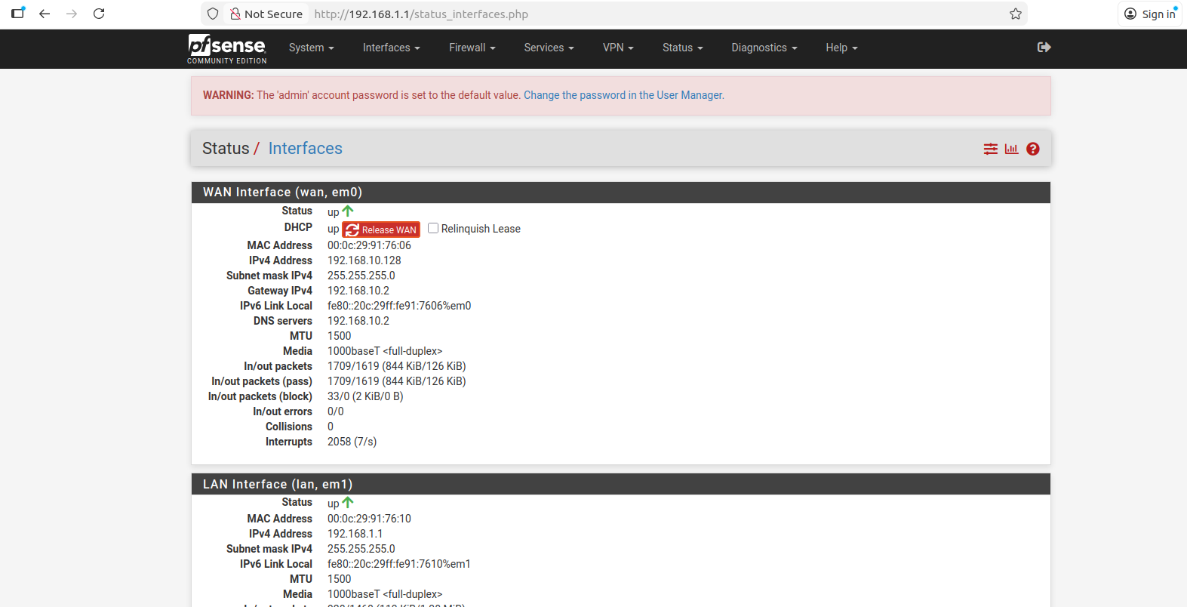

Zeek Installation and LAN Configuration
Zeek was installed on a dedicated Ubuntu 22.04 VM. The latest stable version of Zeek was deployed, and permissions were adjusted to allow the Zeek process to capture packets on the network interface. The Zeek VM was assigned a static IP within the pfSense LAN to maintain a consistent presence on the network.
To monitor the internal LAN, Zeek’s node configuration file (node.cfg) was updated to specify the correct network interface (ens33). Additionally, the lab’s subnet (192.168.1.0/24) was added to Zeek’s networks.cfg file to define the scope of network traffic to monitor. This configuration ensures that all communications between VMs in the LAN, including DNS, HTTP, SSH, and other protocols, are captured and logged for further analysis.
Once configured, Zeek was deployed using zeekctl deploy, and its log directories were verified to confirm that LAN traffic was being captured successfully. Test traffic, including pings and HTTP requests between VMs, was observed in Zeek’s conn.log and dns.log, indicating that the system was correctly monitoring the network.
Zeek dns.log for Traffic between LAN VM (192.168.1.10) and Zeek VM (192.168.1.2):
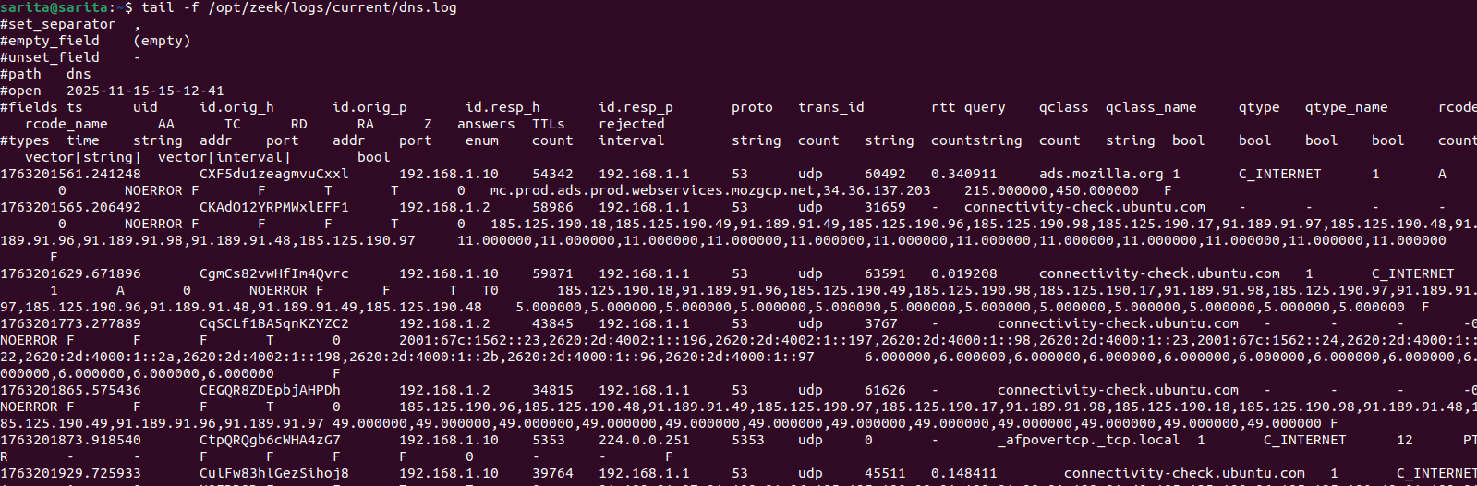

Demonstration of Complex Problem Solving
This project tackles a real-world, complex computing problem, detecting covert DNS tunneling that traditional SIEM rules often miss. It goes beyond simple monitoring by combining multiple interacting components; Zeek for traffic logging, Wazuh for baseline alerts, and machine learning models for dynamic classification.
The challenge lies in identifying sophisticated threats, like short, encoded, or high-entropy tunneling domains, which are designed to evade conventional detection. To solve this, the system analyzes multiple features of each domain and automatically classifies traffic, balancing accuracy, speed, and coverage.
The solution demonstrates critical thinking and problem-solving by:
- Integrating network traffic analysis with ML for adaptive detection.
- Automating feature extraction and prediction to handle large, continuous streams of DNS queries.
- Designing models that are scalable and can evolve as new tunneling techniques appear.
Overall, the project addresses multiple performance and security objectives simultaneously, applying advanced techniques to solve a problem that static configurations alone cannot handle.

Wazuh & Zeek Integration

Wazuh Network Configuration
Before integrating Zeek with Wazuh, the network configuration of the Wazuh VM was adjusted to ensure proper communication over the lab’s host-only LAN. The Wazuh VM was configured with two network interfaces: a NAT interface for internet access and updates, and a Host-Only interface for internal lab communication with Zeek. The Host-Only interface (eth1) was assigned a static IP address of 192.168.1.103/24 with the pfSense LAN gateway (192.168.1.1) and DNS servers configured for name resolution. This setup allows the Zeek VM, which is also on the same Host-Only LAN, to directly reach Wazuh for log forwarding and event correlation, while the NAT interface ensures that Wazuh can still access external resources if required. The configuration was verified by successfully pinging both the pfSense router and the Zeek VM, confirming that the Host-Only network connectivity is operational.

Detailed Steps (Soneye & Singh, n.d.)
- Zeek Installation and Configuration
  - Configured Zeek’s node.cfg and networks.cfg so Zeek monitors the correct network interface and subnet.
  - Edited local.zeek to enable JSON-formatted log output:
  - @load policy/tuning/json-logs.zeek
  - redef LogAscii::use_json = T;
  - Deployed Zeek configuration using zeekctl deploy.
- Verify JSON Log Output
  - Confirmed that Zeek is now writing log files (such as conn.log, dns.log, http.log) in JSON format under /opt/zeek/logs/current/.
  - Used commands like ls and head to inspect the first few lines of the logs and ensure they are valid JSON.
- Configure Wazuh Agent to Collect Zeek Logs
  - On the Wazuh agent, modified /var/ossec/etc/ossec.conf to add a localfile entry:
  - <localfile>
  - <log_format>json</log_format>
  - <location>/opt/zeek/logs/current/*.log</location>
  - </localfile>
This tells the Wazuh agent to read all Zeek JSON logs.
  - Restarted the Wazuh agent (systemctl restart wazuh-agent) so it began monitoring Zeek’s log directory.
- Create Custom Decoders in Wazuh
  - On the Wazuh Dashboard → Server Management → Decoders, added a new decoder file named zeek_decoders.xml.
  - Defined custom JSON decoders for Zeek fields (e.g., ts, uid, id.orig_h, proto, query, etc.) to properly extract relevant fields from the JSON logs.
  - Each <decoder> has <parent>json</parent> to leverage Wazuh’s built-in JSON decoding, then a <regex> to pick up specific fields.
- Create Custom Rules in Wazuh
  - Under Server Management → Rules, created a new rule file zeek_rules.xml.
  - Added a base rule (ID 100900) that triggers for any Zeek JSON event.
  - Defined more specific rules:
    - 100901: DNS query detection (based on dnsquery and resolved_by fields)
    - 100903: Connection rejected (connection_state = REJ)
    - 100904: Port-scan style: multiple rejections in a timeframe
    - 100906 / 100907: SSL/TLS certificate validation issues (e.g., self-signed, expired)
- Restart Wazuh / Apply Changes
  - After saving the decoders and rules on the dashboard, restarted or reloaded Wazuh so the new decoders and rules are active.
  - Verified that alerts start appearing in the Wazuh Dashboard under Security Events.
- Testing the Integration
  - DNS Test: Ran dig against some domains (e.g., wazuh.com) to generate DNS queries; verified that Wazuh triggered rule 100901 when queries resolved.
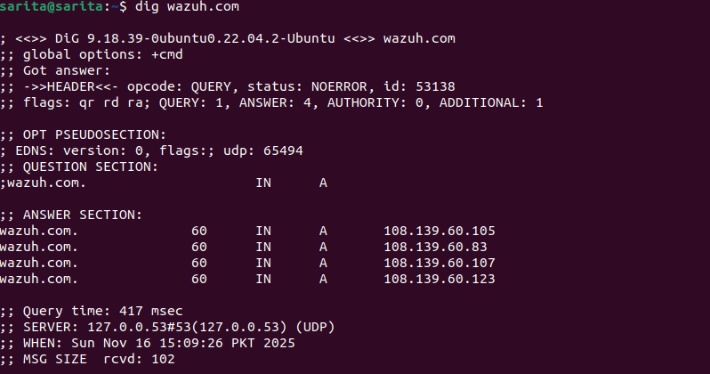
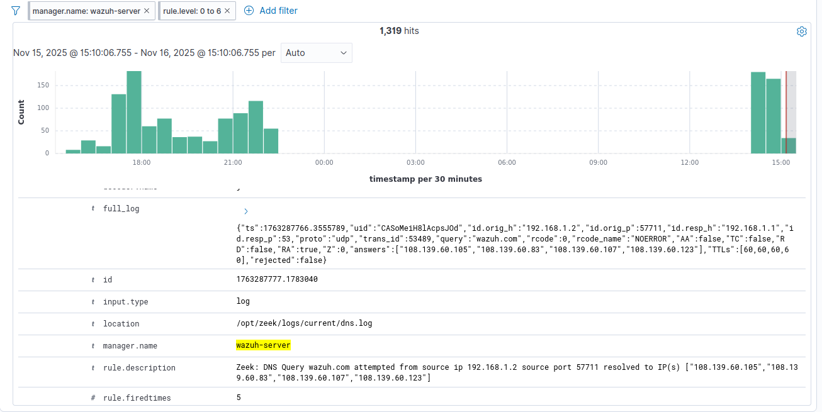
  - Reconnaissance / Port Scan: Simulated multiple connection attempts to unused ports (e.g., using nc -zv) to trigger connection rejections. This caused Wazuh to fire rule 100903, and repeated attempts triggered 100904.
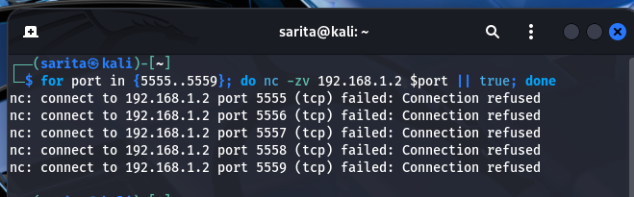
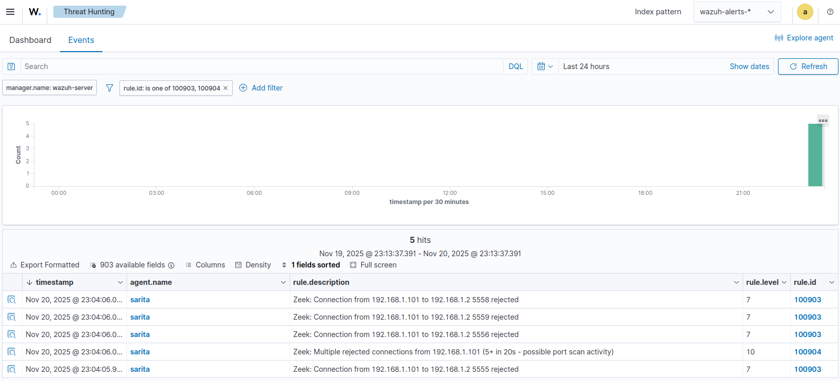
  - SSL Test: Made HTTPS requests to self-signed or expired certificate sites (e.g., curl -k https://self-signed.badssl.com). This triggered SSL validation rules 100906 / 100907.
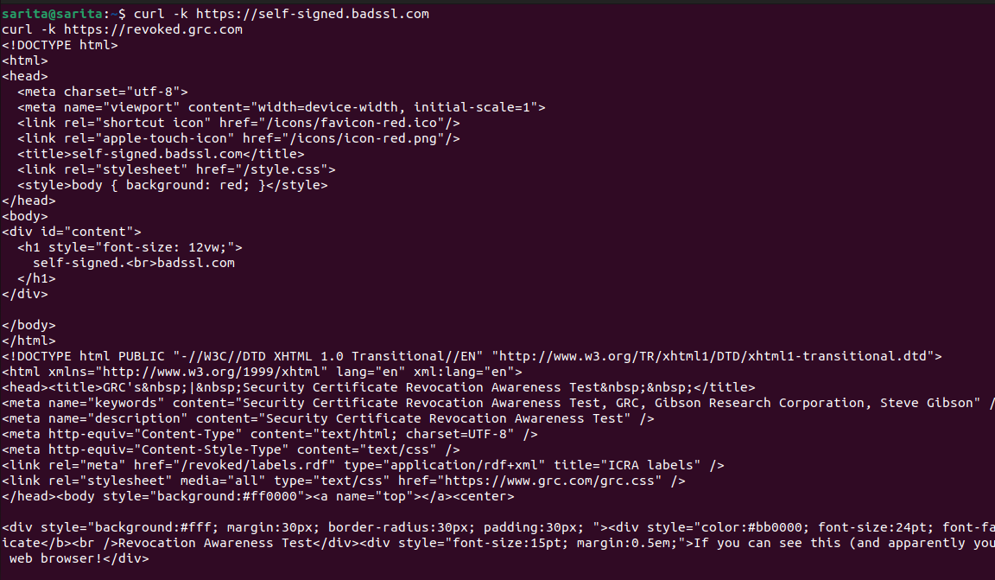
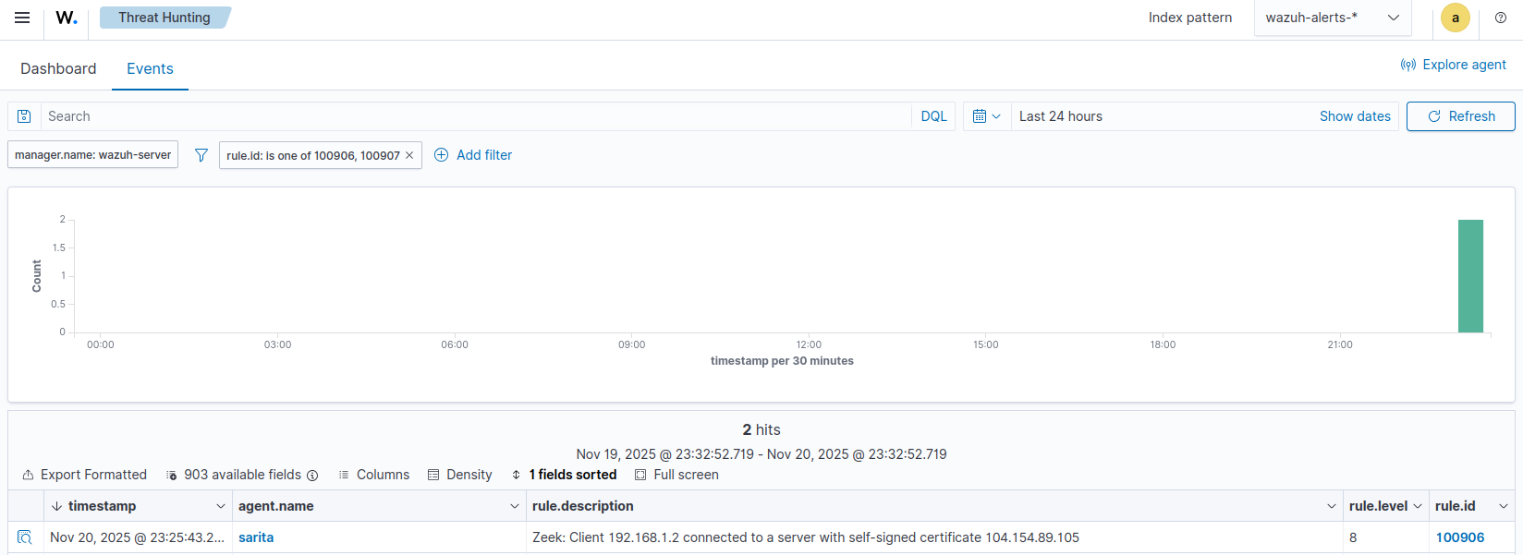

DNS Tunnelling Signature Based Detection
DNS tunnelling is a technique where attackers encapsulate data inside DNS queries and responses to bypass firewalls and monitoring systems. Because DNS traffic is almost always allowed in networks, tunnelling creates a covert communication channel that is difficult to detect using traditional security tools.
In this project, we implemented a DNS tunnelling detection setup using Zeek as the network monitoring sensor and Wazuh as the SIEM and alerting platform. The objective was to generate real DNS tunnelling traffic, observe how Zeek logs it, and then design custom Wazuh rules to detect suspicious tunnelling patterns.

Environment Setup
Our setup had three components:
- Kali Linux Machine: Running the iodine DNS tunnel server
- Ubuntu Machine with Zeek + Wazuh Agent: Running iodine client, generating DNS queries that mimic tunnelling traffic, and forwarding logs to Wazuh
- Wazuh Manager: Parsing Zeek logs and evaluating custom rules
The workflow was:
- Zeek monitors DNS traffic on the Ubuntu machine.
- Iodine (client/server) creates a DNS tunnel, generating DNS queries that appear in Zeek’s DNS logs.
- Wazuh receives these logs and uses custom rules to trigger alerts for DNS tunnelling activity.

Generating DNS Tunnelling Traffic using Iodine (iodine, n.d.)
Iodine Server Setup (Kali)
On the Kali machine, we started the iodine server on port 53:
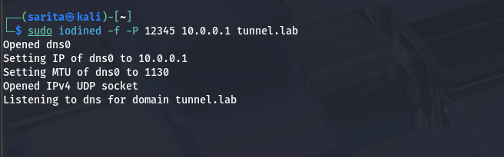
Iodine Client Setup (Ubuntu with Zeek)
On the Zeek sensor machine:
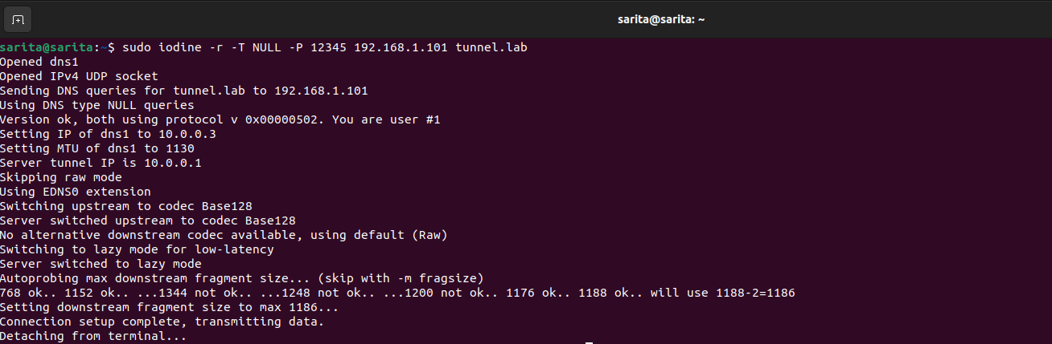

Zeek logs containing DNS tunneling queries
Zeek now sees continuous encoded DNS subdomain queries, for example:
- paiajxmi.tunnel.lab
- pabbwtxi.tunnel.lab
- paiajxma.tunnel.lab
These long, random-looking subdomains are the indicator of DNS tunnelling.
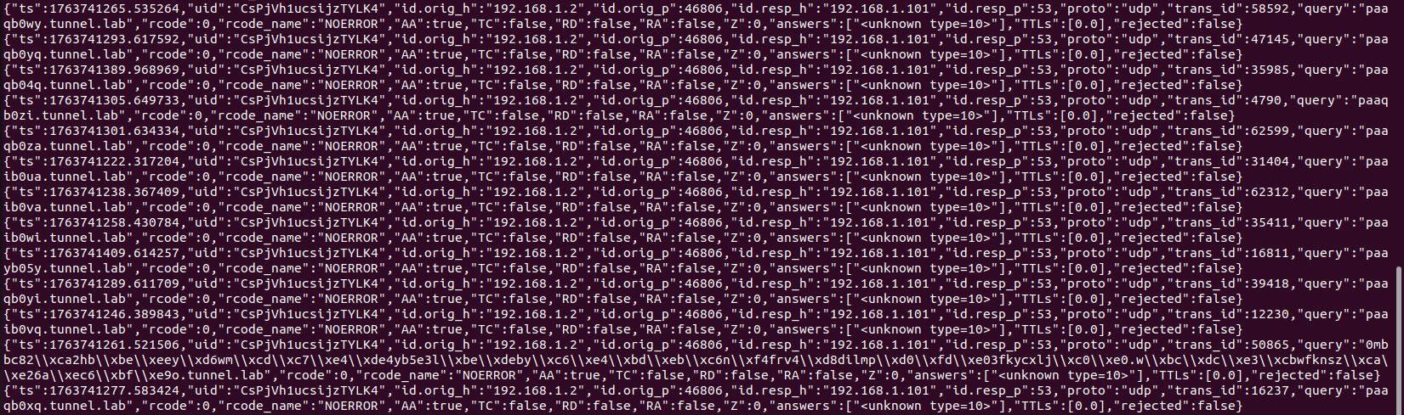

Custom Wazuh Rules for DNS Tunneling Detection
Since Wazuh does not detect DNS tunnelling by default, we created custom rules targeting the tunnelling patterns observed in Zeek logs.
Rule 1: Detect Long, Suspicious DNS Queries
<rule id="100908" level="8">
<if_sid>100900</if_sid>
<field name="dnsquery" type="pcre2">^[A-Za-z0-9\-]{20,}\.</field>
<description>Zeek: Possible DNS tunnelling detected — long encoded DNS query $(dnsquery) from $(srcip)</description>
</rule>
This rule fires when Zeek logs a DNS query with more than 20 alphanumeric characters before the first dot, which is typical of encoded data sent in tunnels.

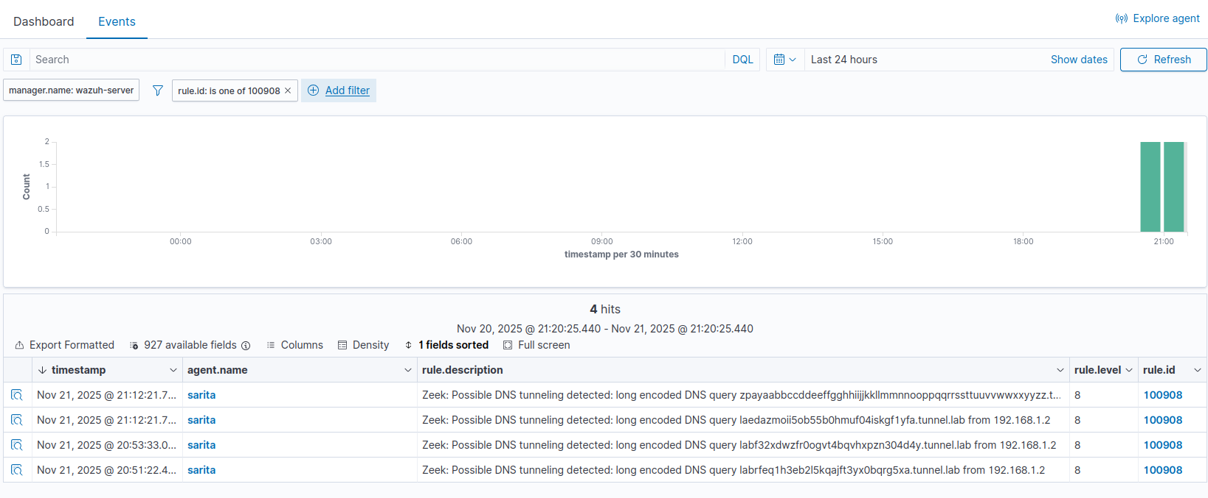
Rule 2: Detect Multiple Suspicious Queries in a Short Timeframe
<rule id="100909" level="10" frequency="10" timeframe="5">
<if_matched_sid>100908</if_matched_sid>
<description>Zeek: Repeated suspicious DNS queries (10+ in 5s) from $(srcip) — potential DNS tunneling activity</description>
</rule>
This rule correlates events and alerts when a source makes 10 or more encoded DNS queries within 5 seconds, which is common in active tunnels.
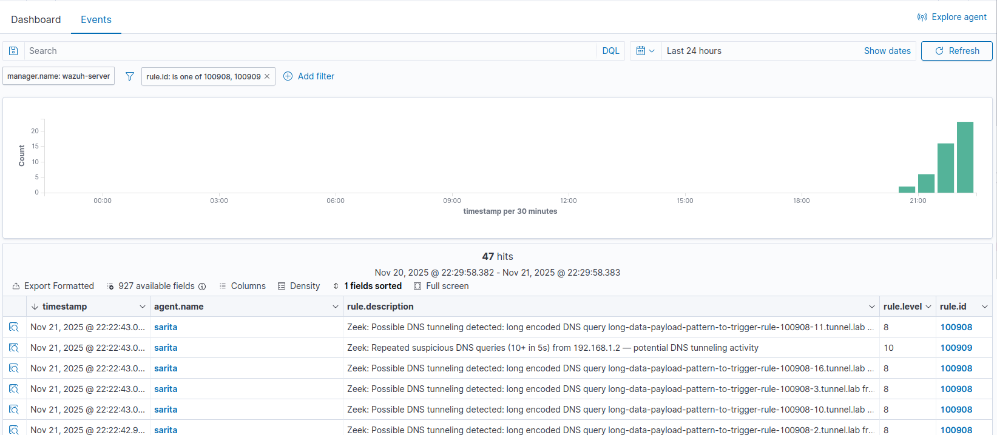

Bypassing the DNS Tunnelling Detection Rules
To test the effectiveness of our detection rules, we attempted to evade them using modified iodine tunnelling parameters. Since rule 100908 relied on detecting long DNS query lengths, our goal was to make the DNS queries shorter so they would not match the pattern.

We launched the iodine client using the following command:
sudo iodine -r -T NULL -O Base32 -M 15 -m 28 -P 12345 192.168.1.101 tunnel.lab
How the Bypass Worked
The key idea was to shrink the size of each DNS query, because our Wazuh rule was triggered only when the query length exceeded a specific threshold. By changing iodine’s encoding and fragment size, we were able to keep the queries short enough to avoid detection. Here are the important flags that contributed to the bypass:
- -T NULL
Using the NULL tunnel type reduces overhead and keeps the DNS labels simpler. This helps produce smaller, cleaner queries that don’t match the long-pattern regex.
- -O Base32
Switching the encoding to Base32 is very important. Base32 produces shorter encoded strings than Base64. Shorter encoded chunks mean the overall DNS query length becomes much smaller.
- -M 15
This controls the maximum fragment size of upstream data. Setting it to a low value forces iodine to send smaller chunks, resulting in shorter DNS labels in each query.
- -m 28
Similar to -M, but for downstream packets. Reducing this also ensures the returned DNS responses don’t produce large or suspicious-looking queries.
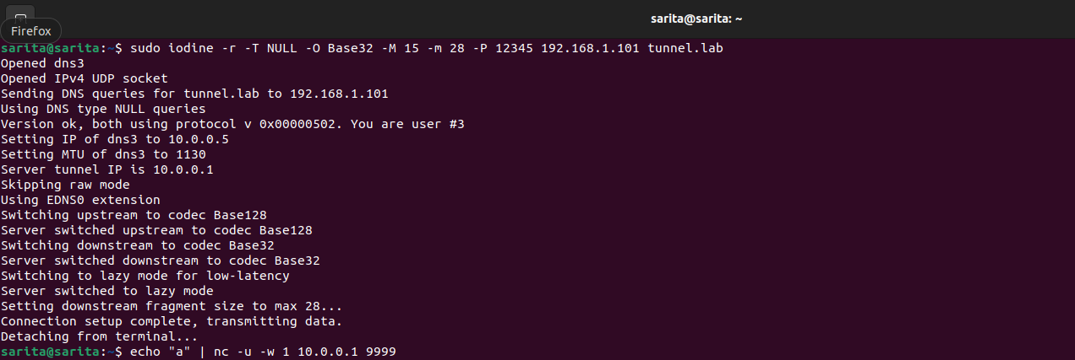
Together, these flags drastically reduced the size of every DNS query. Since our rule 100908 was designed to trigger only on unusually long queries, the shorter encoded queries simply never matched the detection pattern.
Impact on Correlation Rule 100909
Rule 100909 depended entirely on 100908 being triggered first. It was meant to alert when multiple tunnelling attempts occurred within a short timeframe. But once 100908 stopped matching, 100909 also stopped triggering and Wazuh produced zero alerts, even though DNS tunnelling was still happening. So, by bypassing one base rule, we effectively bypassed the entire detection chain.

Zeek Log Results containing Short Queries
The logs initially capture long, structured queries, such as the "alphabet" sequence (zlgtaabbcc...), which are hard-coded calibration packets used by the iodine client to verify the Maximum Transmission Unit (MTU) and connection quality. While these handshake packets triggered the length-based Wazuh alert (Rule 100908), they merely represent the tool's startup noise rather than actual data loss. Crucially, the subsequent operational traffic carrying the actual payload (such as ICMP pings or shell commands) appeared as highly fragmented, short queries like pamacz3i.tunnel.lab (8 characters) and sdhlgw.tunnel.lab (6 characters). Since these data-bearing packets fell significantly below the 20-character detection threshold, they successfully evaded the Wazuh rules. This demonstrates that while the tool's presence was flagged during startup, the continuous data exfiltration channel effectively bypassed the signature-based detection.
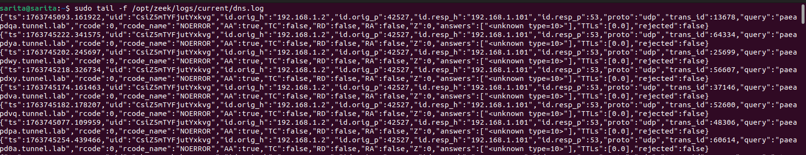

Machine Learning Based DNS Tunneling Detection Setup

Overview
Traditional (non-ML) DNS security relies on static rules, blocklists, and signature-based checks. These rules often fail when attackers generate unseen, randomized, or high-entropy (meaning a domain name is highly random and unpredictable, often indicating it was algorithmically generated) DNS queries, exactly how modern tunneling tools behave. To overcome these limitations, this project implements a Machine Learning (ML) based DNS tunneling detector trained on real DNS traffic and synthetically generated malicious tunneling payloads.
The goal was to compare:
- Non-ML Detection: static DNS rules / blocklists
- ML Detection: entropy- and structure-based classification using RandomForest & XGBoost
This comparison clearly demonstrates how ML generalizes far better to unknown tunneling domains.

Dataset Collection & Lab Setup
To simulate realistic tunneling behavior, I generated malicious DNS queries using iodine, both of which embed data inside DNS subdomains. The lab setup included:
- Kali Linux VM (Attacker)
- Ubuntu VM / Target System running Zeek
- Authoritative DNS domains for tunneling “tunnel.lab” and “exfil.shanzay.lab”
Using these domains, we generated thousands of DNS queries that mimic data exfiltration, command-and-control patterns, high-entropy / base32-like random subdomains and varying lengths (short bursts and long payloads). Zeek captured all DNS activity in dns.log, which was converted to CSV for ML processing.

Dataset Construction
The final dataset combined:
Malicious Queries (Label = 1)
- Synthetic tunneling samples generated through a Python script
- Realistic base32/base64-style subdomains
- Short and long tunneling payloads
- Domains ending in “.tunnel.lab” and “.exfil.shanzay.lab”
Benign Queries (Label = 0)
Collected from normal browsing traffic, common domains like:
- google.com, microsoft.com, facebook.com
- CDN domains
- Tracking + analytics requests
- Local LAN queries

Final Dataset Size
- ~5000 total samples
- Balanced to 75% malicious / 25% benign
- Additional samples added to increase generalization
All samples were shuffled to remove ordering bias.

Feature Engineering
ML models can’t understand raw domain names, so we converted each DNS query into numeric features that represent its structure and randomness.
Extracted Features
Feature | Description
len_full | Total length of DNS query
len_sub | Length of subdomain (where tunneling hides)
entropy | Shannon entropy of entire query
digit_ratio | Ratio of digits to characters
letter_ratio | Ratio of letters to characters
num_dots | Number of labels (chunks split by “.”)
longest_chunk | Length of largest data chunk
base32_ratio | Presence of base32/base64-like characters
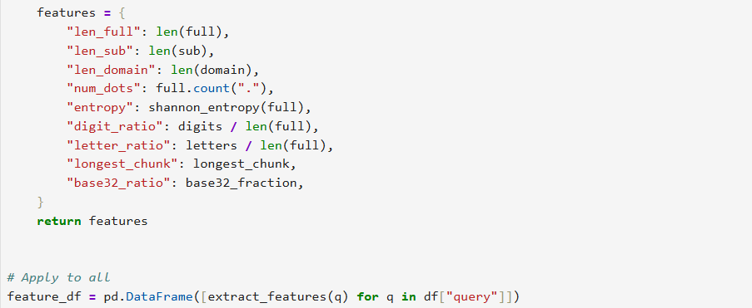
These features capture randomness, encoding patterns, and statistical anomalies in tunneling DNS queries, allowing the model to detect tunneling even if the domain is completely new.
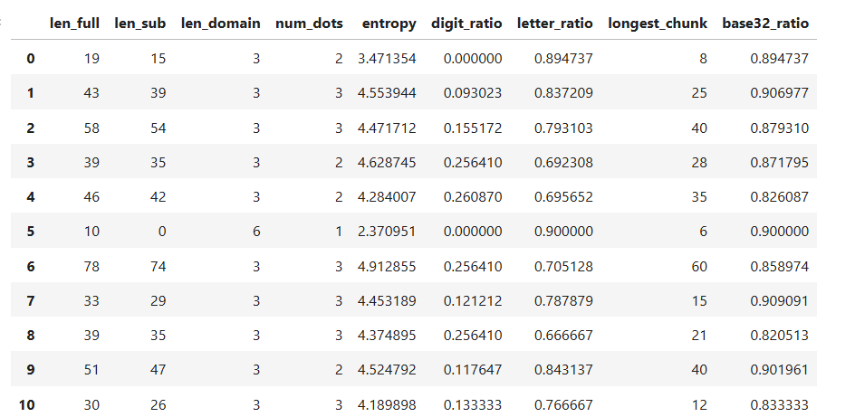

Machine Learning Models Used
Two ML classifiers were trained:

RandomForest Classifier
    - n_estimators = 500
    - class_weight = balanced
    - random_state=42
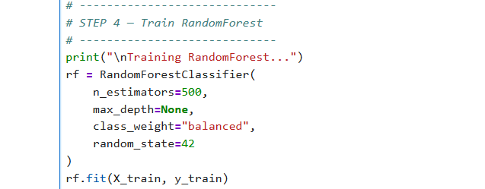
It is excellent for noisy datasets and low risk of overfitting.

XGBoost Classifier (best performer)
- n_estimators = 500
- max_depth = 7
- learning_rate = 0.05
- subsample = 0.8
- colsample_bytree = 0.8
It is designed for tabular anomaly detection, and it handles nonlinear feature interactions extremely well.
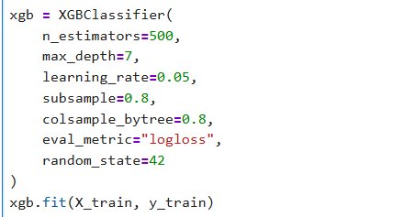
Both models achieved ~99% accuracy during testing, detecting even very short tunneling subdomains. This proves that the ML detector generalizes, not memorizes.
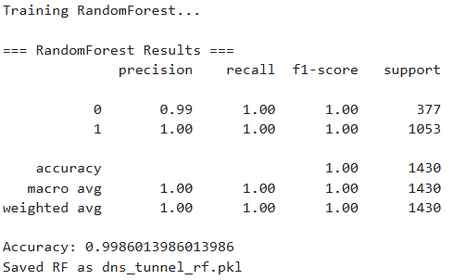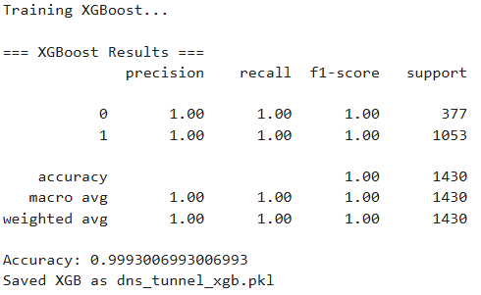

Testing, Evaluation, and Results

On Jupyter Notebook:
Testing involved both synthetic and real DNS traffic. We generated tunneling queries using iodine and created labeled datasets with both normal and tunneling domains.
Metrics and Evaluation:
- RandomForest and XGBoost classifiers achieved near-perfect accuracy (100% on test split for our synthetic dataset).
- Precision and recall showed the models correctly distinguished tunneling domains from normal ones, including short and encoded domains.
- Quantitative results confirmed that ML detection catches threats that static Wazuh rules would miss.
Screenshots of prediction outputs or confusion matrices can be included to illustrate detection performance.
The dns.log from zeek was loaded and tested through these models. It was saved in a separate file.
The below screenshot shows legitimate site browsed:
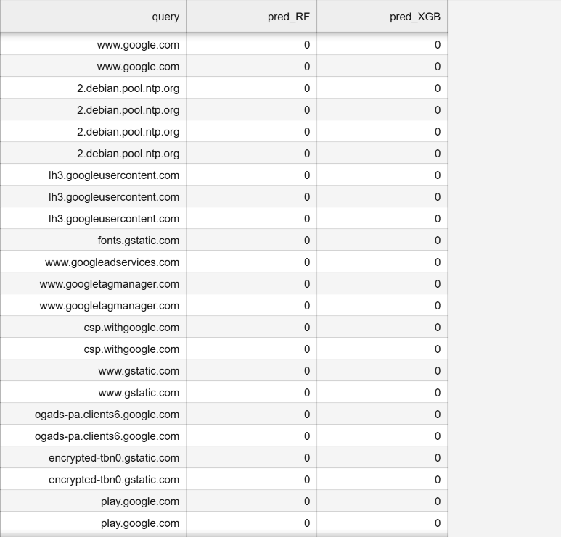
Now the below screenshot shows some tunnelling domains which were generated via iodine.
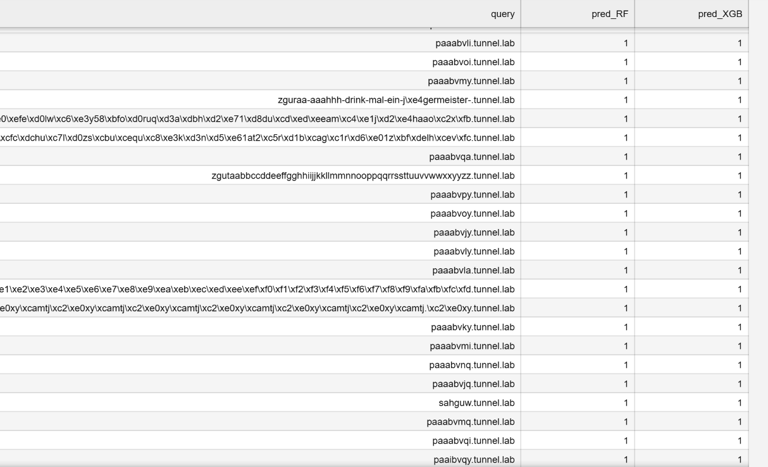

On Wazuh Dashboard using zeek and python script:

Log Normalization (Python Script)
The detection script (dns_ml_detect.py) was modified to output alerts in a specific format that facilitates reliable parsing. Instead of writing raw JSON, which can cause conflict with Wazuh’s default decoders, a custom prefix was added to every positive detection.
When the Random Forest or XGBoost models classify a query as malicious (high entropy/tunneling signature), the script appends the data to /var/log/ml_dns_alerts.log with the prefix ML_ALERT:.
Snippet from dns_ml_detect.py:
# ... Detection logic ...
if tunneling:
full_alert = {
"dns_tunnel_detected": True,
"domain": data["domain"],
"entropy": data["entropy"],
"confidence": data["confidence"],
"timestamp": time.time()
}

# We prefix the log with "ML_ALERT:" to ensure the Wazuh Manager
# uses our custom decoder instead of the default JSON decoder.
json_entry = json.dumps(full_alert)
out.write("ML_ALERT: " + json_entry + "\n")
The Wazuh Agent was configured to read this log file in syslog mode, ensuring the entire line (prefix + JSON) is sent to the Manager for processing.

Custom Log Decoding (local_decoder.xml)
Standard Wazuh decoders cannot natively parse the custom ML_ALERT: format. To resolve this, a custom decoder was defined in /var/ossec/etc/decoders/local_decoder.xml.
This decoder performs two functions:
- Identification: It looks for the specific ^ML_ALERT: header.
- Extraction: It utilizes the JSON_Decoder plugin with an offset, instructing Wazuh to skip the prefix and parse the remaining string as a JSON object. This automatically extracts fields such as domain, entropy, and srcip without complex Regex.
Configuration:
<decoder name="ml_dns_decoder">
<prematch>^ML_ALERT: </prematch>
<plugin_decoder offset="after_prematch">JSON_Decoder</plugin_decoder>
</decoder>

Custom Alerting Rule (local_rules.xml)
With the log decoded and fields extracted, a specific alert rule was created in /var/ossec/etc/rules/local_rules.xml.
The rule is designed to trigger a High Severity alert (Level 12) whenever the ML decoder identifies a tunneling event. Crucially, the rule utilizes the dynamic variable $(domain) extracted by the decoder to populate the alert description with the exact malicious domain name.
Configuration:
<group name="ml_dns,">
<rule id="100200" level="12">
<decoded_as>ml_dns_decoder</decoded_as>

<match>dns_tunnel_detected</match>

<description>ML Detection: DNS Tunneling detected for $(domain)</description>
<options>no_full_log</options>
</rule>
</group>

Screenshots for proof:
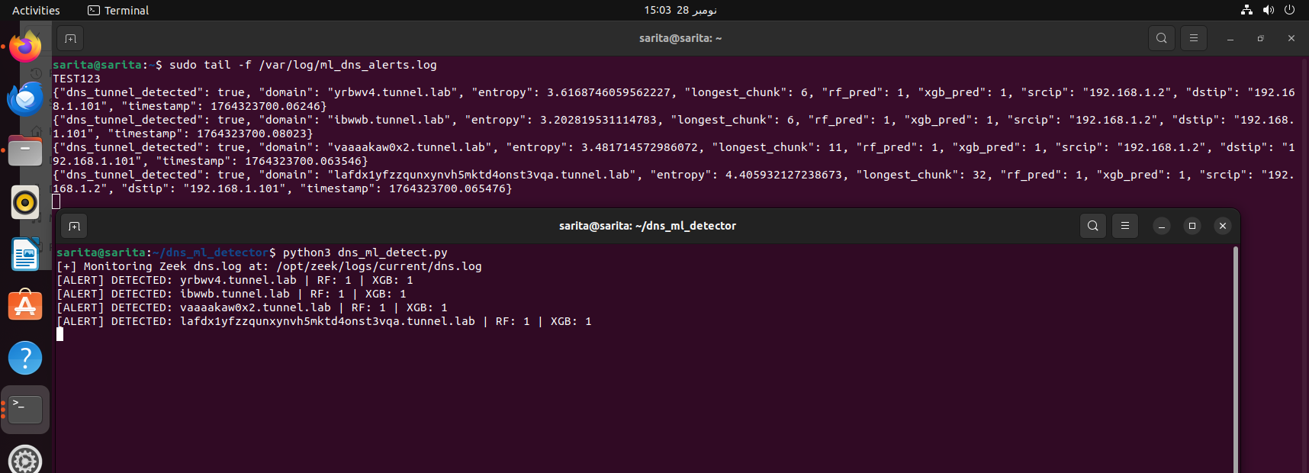
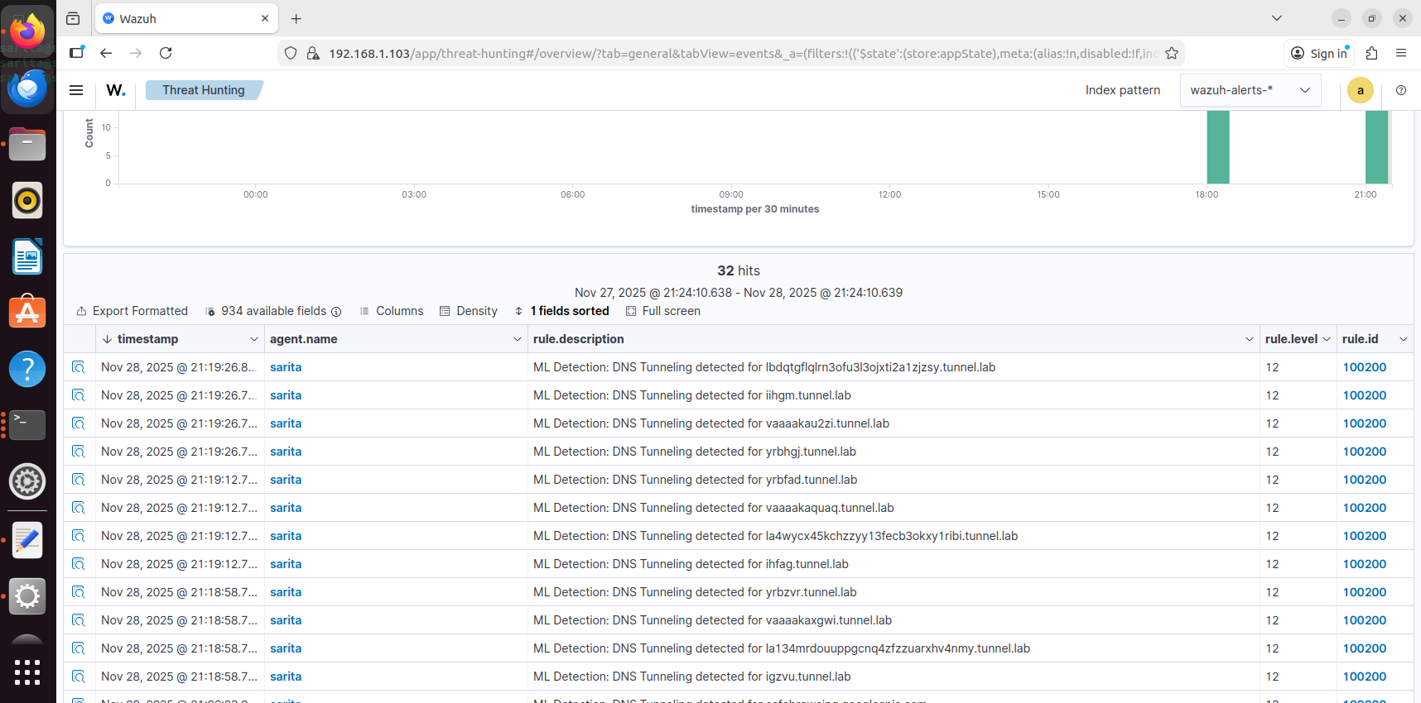

Challenges and Limitations
- Dataset limitations: Only two tunneling domain patterns were initially used, requiring synthetic generation for training.
- Generalization: Models may need retraining when attackers use entirely new tunneling techniques.
- Resource usage: ML adds computational overhead compared to simple rule-based monitoring.
- Integration: Combining Zeek, Wazuh, and ML required careful tuning of workflows and permissions.
In this project, the machine learning models were trained mainly on just two tunneling domain patterns: .tunnel.lab and .exfil.shanzay.lab, along with some synthetic variants. This means that while our system can accurately detect tunneling queries like these, it may not immediately recognize entirely new or unseen tunneling domains. Another challenge is that adding machine learning into the workflow with Zeek and Wazuh introduces extra computational overhead compared to using only static rules. Integrating these tools also required careful setup to ensure logs, permissions, and workflows worked smoothly together. Despite these, the system successfully demonstrates automated, adaptive detection beyond static signatures.

Future Work
For future work, organizations could collect traffic specific to their own networks and train models on a broader variety of tunneling patterns. This would make detection more robust in real-world scenarios. Additionally, adaptive or continuously learning models could be implemented to detect new tunneling behaviors in near real-time, improving long-term resilience.

Conclusion
This project highlights how combining traditional network monitoring with machine learning enhances threat detection. By focusing on DNS tunneling, we showed that static rules alone can miss sophisticated attacks, while ML models can identify even subtle or obfuscated malicious queries. The work demonstrates practical, scalable, and adaptive security, emphasizing automated detection, analytical reasoning, and multi-component system design.

References
- iodine. (n.d.). Retrieved from kali: https://www.kali.org/tools/iodine/
- Soneye, O., & Singh, H. (n.d.). Network security monitoring with Wazuh and Zeek. Retrieved from wazuh: https://wazuh.com/blog/network-security-monitoring-with-wazuh-and-zeek/
- Bubnov, Y. (2019). DNS Tunneling Queries for Binary Classification. Mendeley Data, V1. https://doi.org/10.17632/mzn9hvdcxg.1
- Zeek Network Security Monitor. https://zeek.org/
- Wazuh Open Source Security Platform. https://wazuh.com/
- Chen, T., & Guestrin, C. (2016). XGBoost: A Scalable Tree Boosting System. Proceedings of the 22nd ACM SIGKDD International Conference on Knowledge Discovery and Data Mining.
- Scikit-learn: Machine Learning in Python. https://scikit-learn.org

